1. Compliance Risk Assessment

A reliable risk analysis is key for the success of planned Siemens business goals and strategies. It is also the foundation of the Compliance System. Recognizing risks at an early stage helps management to make informed decisions whether to avoid, reduce, transfer or accept certain compliance risks.

One of the prerequisites for proactively managing those risks is to create transparency in relation to the overall risk environment by evaluating the business exposure, openly and self-critically, to defined Compliance risk areas such as, but not limited, to: Anti-Corruption, Antirust, Export Control, Anti-Money Laundering and Data Privacy within the Entity.

The Compliance Risk Assessment (CRA) is one element of the Compliance Risk Management process. It targets a bottom up evaluation of local risk environment in each Siemens Entity worldwide through the CRA workshop.

During the CRA Workshop CEOs, relevant managers, and Compliance Officers meet to systematically determine and assess compliance risks on their respective companies.

CRA results are then incorporated in the group-level compliance risk analysis. The latter aims to identify systematic and globally recurring compliance risks as quickly as possible. The group-level analyses consider additional factors, such as insights from compliance controls and investigations into specific cases. The corporate compliance risks are derived from the consolidated results, which are shared with the company’s business Entities. Relevant risks are reported to the company’s Enterprise Risk Management (ERM).

Risk-reduction measures are drawn up and implemented. These measures are registered and monitored in the CRA Tracking tool. If significant or major risks arise during a year, the responsible CO reports these risks to LC CO RFC RC directly via e-mail and in the CRA Tracking tool. This Ad-hoc risk reporting does not replace Ad-hoc ERM reporting.

The progress of the derived mitigation measures must be monitored regularly, at least twice a year by the respective Entity Compliance Officer, for example, in the Compliance Review Board (CRB).

Besides the CRA Workshop (see Chapter 1.6.2), the CRA process includes an AREA - Antitrust Risk Exposure Assessment (see Chapter 1.6.1) for relevant Entities (see Chapter 1.4) to perform a top-down / bottom-up risk analysis. Both processes are combined and described in this CRA Handbook.

## 1.1 Purpose

The purpose of this Handbook is to describe how to perform the CRA Workshop and AREA as well as how to define mitigation measures for the identified compliance risks. It also defines the scope and respective frequency.

|  |  |
| --- | --- |
| **CRA** | **AREA** |
| * The goal of the CRA is to evaluate compliance risks within Siemens and to define mitigation measures[1] accordingly. * Moreover, the CRA creates an awareness of compliance risks, emphasizes the responsibility of the entity CEO and management in general for compliance-related topics and strengthens cooperation between the Compliance organization and the business entities. * The CRA process requires, among other things, out-of-the box thinking and input that should be collected by Compliance in an organized fashion from observations in the course of the two-year CRA period[2]. | * The AREA aims to identify the antitrust risk level of the various Siemens entities in a bottom-up manner and to define appropriate follow-up measures. It is carried out by management with the assistance of Legal and Compliance. * The implementation of the appropriate (i.e. risk-based) follow-up measures contributes to minimizing antitrust risks across the Siemens Group. |

## 1.2. CRA Workshop Benefits

The CRA Workshop supports the CEO and the respective management in:

* Identifying potential compliance-related risks (resulting in direct/indirect liability, reputational harm) beyond those already mitigated by existing compliance circulars, tools and controls;
* Incorporating company experience from investigations, audit findings and other deficiencies to identify potential sources of compliance-related risks;
* Deciding whether to avoid, reduce, transfer or accept certain compliance risks;
* Determining appropriate ways to limit the impact of certain risks those risks (mitigating actions);
* Creating awareness of a compliance risk culture, supporting the CEO on his/her responsibility for risk management and compliance-related topics
* Gaining a clear understanding of possible underlying compliance risks related to anticorruption, antitrust data privacy, anti-money laundering, human rights and export control.
* Strengthens cooperation between the Compliance organization and the Business Entities.

## 1.3 Stakeholders

CRA Workshop

The Entity CEO is responsible for the CRA Workshop execution as well as for the definition of the relevant mitigation measures, thus for the CRA Workshop results.

The Compliance Officer (CO) of each applicable Entity and Region is responsible for coordination and preparation of the CRA workshop (with support and input from the relevant Regional Experts on risk identified, e.g. antitrust expert for AREA aspects). The CO also reports the workshop results to the Risk Management and Controls department (LC CO RFC RC) and is responsible for tracking and monitoring the implementation status of any defined mitigation measures.

Management’s proximity to the business renders it close to potential compliance risks, thus Management’s input is, therefore, a key source for every risk assessment process.

AREA

The CEO and the General Counsel of the entity are mandatory participants

Optional participants are:

* The representatives of the Strategy and Sales department or Business Development
* Other potential stakeholders, such as (for the Lead/Assigned Country AREA meeting) the relevant Regional Antitrust Expert

## 1.4. Scope

The **CRA workshop** is applicable to the following levels and therefore should be executed in accordance to this guidance:

|  |  |
| --- | --- |
| **\*“CRA Entity”** | **“CRA Region”** |
| * Operating Companies * Corporate Development Unit * Service Companies and * Strategic Companies “Mobility” | * Corporate Country * Lead Countries * *Top Risk Countries[3]* |

*Please refer to Annex 1 for a listing of applicable units and regions

The **AREA process** applies to the following entities:

1. Business Units and Business Segments of the Operating Company Gas and Power;
2. Business Units of the Operating Company Smart Infrastructure;
3. Business Units of the Operating Company Digital Industries;
4. All Corporate Countries (incl. for China the Countries / Regions reporting and for India the Countries reporting to the respective Corporate Country);
5. Business Units and Regions of the Strategic Company Mobility;
6. All Lead Countries and Assigned Countries, irrespective of which Operating Company they report to;
7. Selected central entities, namely: Financial Services (SFS), Corporate Technology (CT), Internet of Things (IOT), Next47 (N47), Portfolio Companies (POC) and Human Resources (HR).

For the *following Regional Companies (“Top 15 AREA Countries”): Austria, Brazil, Canada, China, Denmark, France, Germany, India, Italy, Japan, Saudi Arabia, Switzerland, Spain, United Kingdom and USA, the AREA must be conducted at the Country Operating Company level (including Country Business Unit split), unless the turnover of a Country Operating Company in the respective Regional Company in the last completed financial year was less than €15 million. For all Regional Companies that are not Top 15 AREA Countries, the split by business (Country Operating Company, including Country Business Unit) is optional. The AREA must not be carried out at ARE-level. The AREA results should feed into the CRA preparation.*

List of applicable units and regions for CRA 2020

CRA Entity

Operating Companies:

Gas and Power

Smart Infrastructure

Digital Industries

Strategic Company:

Siemens Mobility

Service Companies:

Financial Services

Global Business Services

Real Estate Services

Corporate Development Unit:

Internet of Things

Portfolio Companies

CRA Region

Corporate Countries:

China

Germany (?)

India

United States

Lead Countries:

Morocco

Nigeria

South Africa

United Arab Emirates

Australia

Canada

Switzerland

France

Mexico

Saudi Arabia

Singapore

Turkey

United Kingdom

Argentina

Austria

Brazil

Spain

Italy

Japan

Netherlands

Republic of Korea

Russian Federation

Sweden

“Top Risk” Countries will be subject to CRA Workshops in FY2021

## 1.5. Frequency and Timeline

The CRA Workshop must be performed by the respective Entities in scope every two years, starting from FY2020.

The Antitrust Risk Assessment (AREA) must be executed as a mandatory element of the CRA Workshop as described in Chapter 1.6.1

In odd years, the so-called Top Risk Countries are required to perform a CRA Workshop.

The CRA workshop results must be documented by the end of Q1 of the Fiscal Year.

***Note that in order to support the worldwide responsibility of the Operating Companies for their business, the “Region CRA workshops” (refer to Chapter 1.4) shall be scheduled first, in October/early November and make the CRA Workshop results available in mid-November for use in the Operating Company CRA’s.***

***The “Company CRA workshops” (refer to*** ***Chapter 1.4******) shall perform their CRA’s in late November/December.***

***The progress of the derived mitigation measures must be monitored regularly, at least twice a year by the respective entity, for example, in the Compliance Review Board (CRB, refer to Chapter K. 2.).***

## 1.6. CRA Workshop Process Description

The CRA process is divided into six steps. Each step is described in more detail in the following chapters:

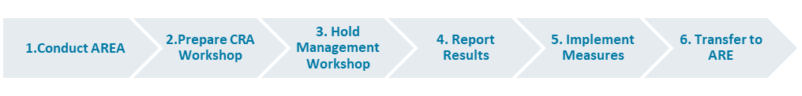

Step 1 (Details see chapter 1.6.1 AREA, not applicable for Top Risk Countries when performing a CRA in odd fiscal years):

The AREA is the first step that must be taken. The AREA aims to identify the antitrust risk level of the various Siemens Entities and to define appropriate follow-up measures. It is carried out by management with the assistance of Legal and Compliance.

Step 2 (Details see chapter 1.6.2 Workshop Preparation):

The second step "Preparation" aims to reunite supporting information and key facts to support risk exposure discussions with management. The Entity responsible CO reviews the previous CRA results and defines the frame conditions by analyzing data from different internal and external sources (such as previous or pending cases, reviews and external audits), conducting interviews and preparing the workshop slides (with input from the relevant Regional Antitrust Experts on antitrust/AREA aspects) with key hypotheses and risks agreed with the CEO of the entity.

Step 3 (Details see chapter 1.6.3 Hold Management Workshop):

The CEO is responsible for the CRA results and emphasizes this responsibility by issuing invitations to the CRA workshop.

Step 4 (Details see chapter 1.6.4 Reporting of CRA Workshop Results):

Results are transferred to ERM, if applicable.

Step 5 (Details see chapter 1.6.5 Measures Implementation):

Focus on the response plan. A tool is provided and serves two purposes. Firstly, it serves as input for the further analysis of compliance risks on an aggregate level by LC CO RFC RC. Secondly, the CRA tracking tool can be used by the entity to implement the response plan and monitor the mitigation measures.

The results of the CRA and the mitigation measures, as well as the implementation of the latter, must be discussed and monitored regularly (at least twice a year) during Management Meetings (such as CRB).

Step 6 (Details see chapter 1.6.6 Transfer to ARE):

Finally, the CRA results are transferred to the AREs. Within the AREs, management reviews the CRA results and implements mitigation measures if applicable. In the case of newly identified risks that have not been reported by the CRA Entities and CRA regions so far, should be reported by the responsible CO of the ARE accordingly.

### 1.6.1. Conduct an Antitrust Risk Exposure Assessment

To conduct and Antitrust Risk Exposure Assessment (AREA) is the first step that must be taken. The AREA aims to identify the antitrust risk level of the various Siemens Entities and to define appropriate follow-up measures. It is carried out by management with the assistance of Legal and Compliance.

The AREA Step 1. is not applicable for Top Risk Countries who only perform a CRA workshop, consisting of Steps 2 to 6 in odd fiscal years:

The following figure provides an overview of the process step “Conduct AREA”.

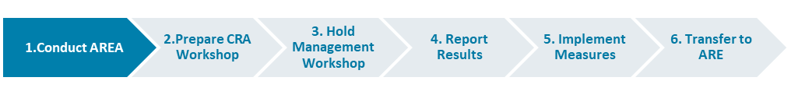

* 1. Instruct sub-levels: The relevant OpCo CO, Corporate Country CO (for China and India) and the Lead Country CO inform the relevant COs responsible for the entities listed in 1.4 above about the current AREA process and the tasks to be performed. The COs responsible for Regional Companies inform the relevant Regional Antitrust Expert accordingly.
  2. Prepare Meeting: The respective CO responsible for the entities listed in 1.4 above must prepare the AREA meeting together, in the case of Regional Companies, with the relevant Regional Antitrust Expert. He can optionally discuss in advance the antitrust-related questions contained in the Excel template (see [risk department](https://intranet.siemens.com/en/Compliance/topics/Compliance_risk_assessment.htm) or [LC M&A CMP homepage](https://intranet.for.siemens.com/org/lc/en/legal/orga/cmp/Pages/cmp.aspx?tabcardname=area)) with the General/ Legal Counsel and selected Key Support Functions. As a further preparation step, the Business Unit/Regional Company CO together with the Regional Antitrust Expert must review antitrust-related cases in TRACI within his area of responsibility.
  3. Conduct meeting: During the AREA meeting, the antitrust-related questions must be answered, and the CEO is required to sign the results.
  4. Define measures: Completion of the questions in the relevant AREA template will result in an overall antitrust risk rating of low/medium/high. Based on this rating, management is required with the assistance of Legal and Compliance to determine, implement and document appropriate follow-up measures (recommended measures are provided on risk department / LC M&A CMP homepage). The defined follow-up measures can also be used for CRA mitigation measures. Please note that if a “high” antitrust risk has been identified, LC M&A CMP and LC CO IR must be consulted prior to determining the appropriate follow-up measures. In all other cases, LC M&A CMP and LC CO IR may choose to verify any entity's bottom-up risk assessment and follow-up measures in a top-down approach. The Monitoring Sheet provided on risk department / LC M&A CMP homepage can be used to monitor the implementation progress of defined follow-up measures.
  5. Report results: Finally, the Excel file containing the AREA results must be sent by encrypted email to LC M&A CMP using the following email address ([area-results.legal-compliance@siemens.com](mailto:area-results.legal-compliance@siemens.com)) and indicating in the subject line which entity the AREA results relate to. Once the Excel file has been sent to LC M&A CMP, the original signed document should be filed locally. For further information on the AREA and the applicable AREA templates please consult the [LC M&A CMP intranet homepage](https://intranet.for.siemens.com/org/lc/en/legal/orga/cmp/Pages/cmp.aspx) or the Q&A (see risk department / LC M&A CMP homepage).

### 1.6.2. Prepare CRA Workshop

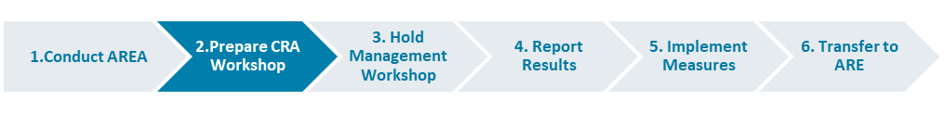

The second step "Preparation" aims to reunite supporting information and key facts to support risk exposure discussions with management.

The responsible CO of the entity (with input from the relevant regional risk topics experts) reviews previous CRA results and defines the frame conditions by analyzing data from different internal and external sources (such as previous or pending cases, reviews and external audits), conducting interviews and preparing the workshop slides (with input from the relevant regional risk topics experts) with key hypotheses and risks agreed with the CEO of the entity.

The respective CO is responsible (with input from the relevant regional risk topics experts) for the preparation of the CRA workshop, whereas the CEO is responsible for the CRA results. The CEO should therefore be informed about the critical points of the analysis during the preparation phase.

#### 1.6.2.1 Review Mandatory Inputs

In general, only the risk and mitigation measures from the previous CRA[4] and the previous AREA results are mandatory input, but (for thorough preparation) other inputs are recommended in order to obtain a complete picture of the compliance risk situation. Central material has been prepared and can be used to facilitate discussions with the responsible risk owners. These materials will be part of the training sessions.

1. Previous CRA results: Review mitigation measures taken, especially if they are still open. The CO and the CEO decide for each open response measure from the previous assessment whether to close it or to transfer it to the new CRA risk identification.
2. Previous AREA results: The last available AREA should feed into the CRA preparation phase. For further information on the AREA and the corresponding AREA templates, consult the [LC](https://intranet.w1.siemens.com/cms/legal/en/sfs/Pages/comp.aspx?tabcardname=AREA) M&A CMP intranet homepage.

#### 1.6.2.2. Review and analyze available data

The goal is to perform an analysis of the business activities and processes in order to understand the possible underlying compliance risks. It is highly recommended that the responsible CO (with input from the relevant regional risk topics experts) analyzes any information and reports he may already have on hand. This helps to refresh the awareness of the compliance topics already addressed through circulars and tools.

#### 1.6.2.3. Prepare key risks for discussions

The last step before the management workshop is to concentrate the analysis on certain key statements and to focus the risk identification on certain risk areas. The risk areas provide plenty of risk examples and potential mitigation measures. Specific risk descriptions that don’t fit into predefined risk areas can be described under the risk area "Individual risks" (see CRA training slides). The COs are responsible (with input from the relevant regional risk topics experts) for summarizing this information. They are encouraged to prepare critical questions to be asked at the management workshop.

### 1.6.3. Hold Management Workshop

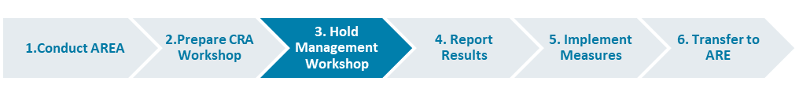

The CEO is responsible for the CRA results and emphasizes this responsibility by issuing invitations to the CRA workshop.

The management workshop is the core activity in the process. During the workshop, management discusses, identifies and analyzes the compliance risks for the entity. Decisions are taken regarding the importance and priority of the risks and the corresponding mitigation measures.

#### 1.6.3.1. Invitation of participant

The responsible CO consults with the CEO based on the discussion with the relevant risk regional experts, to decide who should participate in the CRA management workshop and whether one or more CRA workshops (split by Regions, Business Units or functions) need to be held. The agreed dates should be communicated to LC CO RFC RC.

A certified public accountant (such as Ernst & Young) has the right to participate in the management CRA workshop.

The meeting invitation to the management workshop is sent by the CEO, or the CEO and the responsible CO jointly.

It is highly recommended that the CRA workshop is held prior to the entity's ERM workshop.

#### 1.6.3.2. Execution of Management Workshop

Consider that the time assigned for the workshop should allow enough time for deep discussions and measures description.

The already identified hypotheses and risks during the preparation phase shall be discussed and agreed with management during this workshop.

in order to identify potential new compliance risks a creative brainstorming session shall be conducted in the workshop to encourage participants to "think outside the box". Without this brainstorming session it might happen that only known risks and patterns are identified but new arising topics might be overlooked or are identified too late.

The risks identified are prioritized to obtain a rating of all risks. The rating order is from Top 1 (the most critical risks, the most important risks for the entity and the risks that most urgently require mitigation measures to be defined and implemented) to Top 5.

All risks defined in the CRA management workshop must be classified for Enterprise Risk Management (ERM) ad-hoc reporting relevancy, based on management judgment. Relevant risks must subsequently be treated according to the ERM process and assessed with the ERM methodology.

Finally, a response plan for all risks must be created with the following information:

* Risk description: “there is a risk that…, which may lead to…”
* Measure
* Risk Owner
* Relevant for ERM reporting (Y/N)
* Transferred from last CRA (Y/N)
* Priority (Level 1-5)

Note that an existing compliance case cannot be reported as a risk within the CRA process because, in logical terms, this risk has already materialized.

HR relevant risks are not to be reported in the CRA workshop, contact HR department to address them accordingly.

### 1.6.4. Report CRA Workshop Results

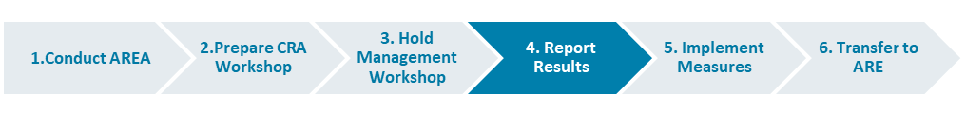

The results of the CRA workshops and the local monitoring of response plans were formerly reported in Excel, without the possibility of a central evaluation in a timely manner. The use of the known CRA Input Sheets and the CRA SharePoint is discontinued. Based on the Audit Management System (AMS) of CF RIC ATC, a new Compliance Risk Tracking Tool is provided that ensures reporting and allows local tool-based monitoring of response plans implementation as well as central analysis. As an additional function, notification e-mails have been configured to alert people in charge of implementation, informing them about newly created response plans and the reaching of deadlines.

The new tool is available as of now (CRA2018) for the Top-Risk Countries 2018 and must be used starting from CRA2020 for the CRA Entities and CRA Regions.

Identified compliance risks and their corresponding mitigation measures have to be entered in the CRA tracking tool accessible here: <https://revweb.siemens.net/ams/index.cfm?go=app.welcome> PKI login. The responsible Compliance Officers of the CRA Entities and CRA Regions are currently registered as users. For further access rights please contact [LC](mailto:CRA.legal-compliance@internal.siemens.com) CO RFC RC

The implementation of the mitigation measures must be documented promptly in the CRA tracking tool to enable local and central tracking.

The MoM of the CRA workshop should be sent via email to the Risk Management and Mitigation department (LC CO RFC RC) as evidence for CCP controls and EY.

#### 1.6.4.1. Reporting to ERM

The responsible CO reviews the management workshop results, ensuring that the underlying risk description and mitigation measures are understandable. Then he informs the relevant risk owner of his assignment. The CO works with the risk owner to implement appropriate mitigation measures.

ERM is designed to manage risk rather than eliminate it completely, and to provide a degree of assurance covering all business objectives of Siemens. CRA complements the ERM process to broaden the identification of potential compliance risks, and thus serves as a qualified ERM input.

The following figure provides an overview of the process step "Report to ERM".

|  |  |
| --- | --- |
| **CRA** | **ERM** |
| * Internal compliance risk assessment process * Focuses purely on compliance risks, ranked by prioritization * No central status reporting of mitigation measures * Entity is responsible for timely risk mitigation * Basis for internal compliance risk analysis | * Enterprise risk management system * Broad focus on strategic, operational, compliance and financial perspective * Quarterly reporting to Corporate RIC Board * Entity is responsible for timely mitigating risks * Basis for external disclosure of risks and opportunities for SAG |

The CRA provides a structured and harmonized approach to prepare a qualified annual ERM workshop. The CRA serves as a filter to ERM. Not all compliance risks will be reported to ERM (based upon management judgment). When applying management judgment, it is recommended that the impact on the overall business objectives of an entity be considered, represented by the ERM impact dimensions.

Option 1: One compliance risk entered in the CRA equals one risk in ERM.

Option 2: Several compliance risks entered in the CRA are combined to form one risk in ERM.

Option 3: The compliance risk entered in the CRA is of no relevance to ERM.

### 1.6.5. Implement Measures

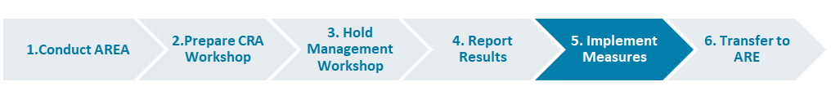

The responsible CO reviews the management workshop results (with input from the relevant Regional Antitrust Experts on antitrust/AREA aspects), ensuring that the underlying risk description and mitigation measures are understandable. Then he informs the relevant risk owner of his assignment. The CO works with the risk owner and with the Regional Antitrust Expert regarding identified antitrust risks to implement appropriate mitigation measures.

Once the defined response plan has been approved by the CEO and entered in the CRA tracking tool, the mitigation measures need to be implemented, tracked in the tool and their status to be monitored regularly. The responsible CO informs the management at least bi-annually, for example in CRB, about the risk’s status and the status of mitigation measures.

Risks reported to ERM follow the [ERM process](https://intranet.w1.siemens.com/cms/finance-controlling/en/org/dep/cfric/tm/Pages/tm.aspx) as well as the entity's internal risk mitigation process.

### 1.6.6. Transfer to AREs

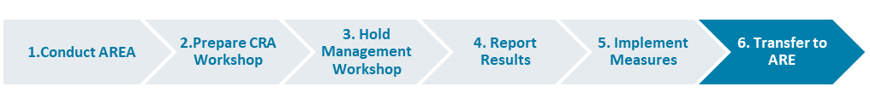

The final step is to transfer the results of the CRA to the AREs of the corresponding Entities. The following figure provides an overview of the process step "Transfer to ARE". This is only required for Audit Category 1 and Category 2 Entities (for further details, see the [Compliance ARE Master list](https://findit.compliance.siemens.com/content/10000101/Compliance/LC_CO/LC_CO_STR_SP/findIT_LC_CO_STR_SP_4272.xlsx)).

The responsible CO of the respective CRA Entity and CRA Region distributes the CRA Workshop results according to their area of responsibility or the assigned AREs respectively, by the end of Q1.

Within the ARE, the CO and ARE Management can define and implement additional mitigation measures for the relevant risks of the ARE. The risks and the response plan status of the ARE risks must be monitored within the ARE. This does not impact the reporting and monitoring defined for CRA Entity and CRA Region.

## 1.7. History of changes

|  |  |  |
| --- | --- | --- |
| **Date** | **Author** | **Major changes of binding content** |
| January 1, 2019 | Thomas Mark  (LC CO GR RM) | First release through Compliance Handbook based on former CRA Web-Book. |
| August9, 2019 | Thomas Mark  (LC CO GR RM)  Andrew Copland-Cale (LC CO GR RM)  Jennifer Garcia Rodriguez  (LC CO GR RM)  Gordon Christian  (LC M&A CMP) | Adjustments to the text to reflect the new Siemens organizational structure, structure changes and editorial simplifications |
| January 1, 2020 | Koen Miezenbeek (LC CO RFC LF) | Update due to organizational changes |

## 1.8. Contacts

Compliance Officer

The Compliance Officer responsible for your unit can be found through the following [link](https://intranet.for.siemens.com/cms/059/en/about/org/Pages/compliance_organization.aspx).

Corporate Governance Owner

[Jennifer Garcia Rodriguez](https://scd.siemens.com/luz/IdentitySearch?cn=Z002CDAJ&maxanz=50&suchart=schnell&utI=I&utX=X&utT=T&rtH=H&rtS=S&rtZ=Z&rtO=O&rtAktiv=A) (LC CO RFC RC)

AREA: [Georg Böttcher](https://scd.siemens.com/luz/IdentitySearch?cn=BOETTCHER+GEORG+Z001PJ1T&tcgid=Z001PJ1T&c=DE&o=SIEMENS&ou=LC&l=MCH+P&department=LC+M%26A+CMP&&utI=I&utX=X&utT=T&rtH=H&rtS=S&rtZ=Z&rtO=O&rtAktiv=A) (LC M&A CMP)

1. Mitigation measures/plan and response measures/plan are used synonymously
2. Recommended by Gibson Dunn in its 360°-Compliance Review Report in November 2015
3. Note that the so-called “Top Risk Countries”, defined by the Compliance Management Team, are also required to perform a CRA Workshop (without AREA) on alternate years.
4. If applicable